 | NON-CONFORMITY REPORT FOR ASSESSMENT VISIT | F-02/06  Issue Date: 08/07/08  Rev No: 05

ACTIVITY: | Assessment Surveillance  Re-Assessment Scope extension  Other Please specify: |  | NCR No: | 02
ACTIVITY: |  |  | Accr./Appl.No:
ACTIVITY: |  |  | Non-conformity category:  Very serious  Essential
ORGANIZATION: | Quality control Lab vital Agri. Nutrients (Pvt) ltd. |  | Time limit for correction:
Department: | Lab |  | 6 weeks
Lead Assessor. | Atique-ur-Rehman | Mngt. Rep. | Mr. Muhammad Ameen
Assessor | Dr. Muhammad Aftab | Mngt. Rep.
Expert |  | Mngt. Rep.
DESCRIPTION:  the lab has developed the Equipment maintenance records sheet (QCL-FRM-4.03) and records related to Equipment maintenance is not maintained (NC)  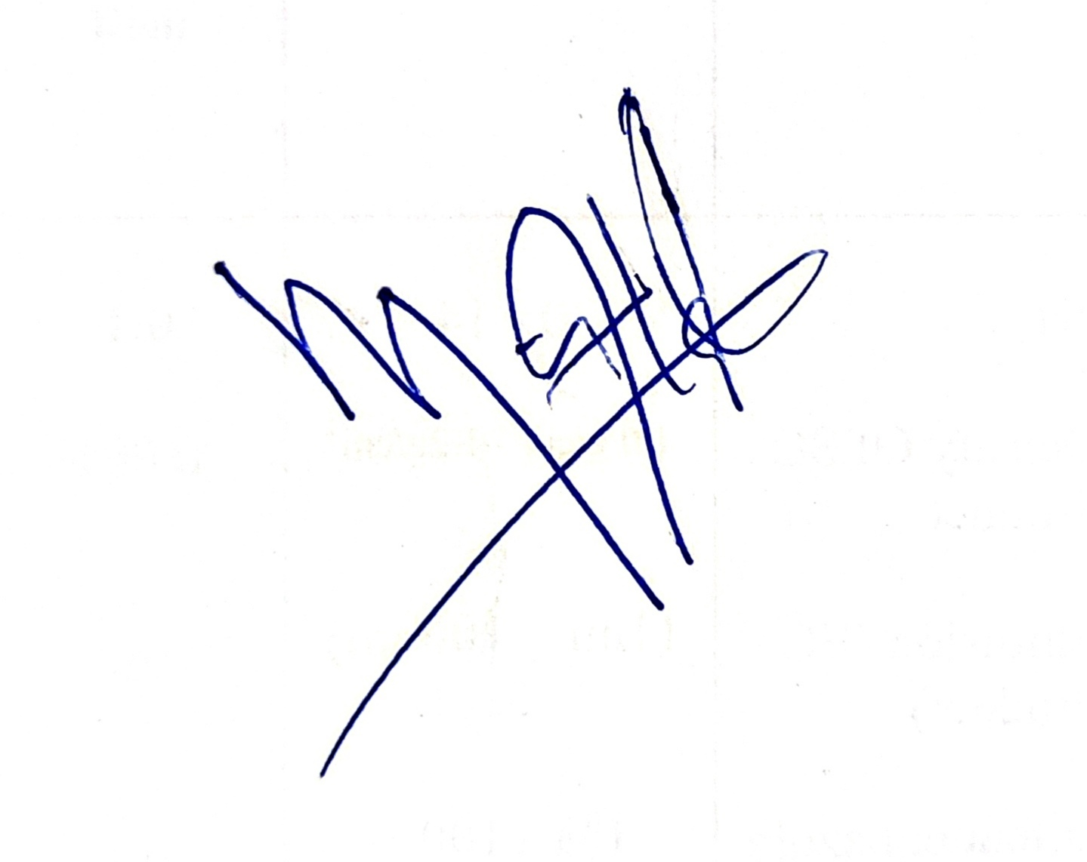  06-06-2026 ______________ ________________________  Date Signature Assessor/Expert Signature (Management Representative) |  |  | Requirement of:  ISO/IEC 17025 6.5  ISO 15189  ISO/IEC 17021  ISO/IEC 17020  Others:
 |  |  | Ref. Organization’s doc.
CORRECTIVE ACTIONS:  Responsibility for maintaining QCL-FRM-4.03 was assigned, and periodic review of equipment maintenance records was included in the laboratory equipment monitoring system.  Action are documented in the amendment no: ___________________  _________________ ________________________________  Date Signature (Management. Representative) |  |  | It is not necessary to attach documentation
REASON FOR CLOSING: (To be filled in by the lead assessor)

The non-conformity is closed based on satisfactory documentation from the organization
The non-conformity is closed based on recommendation from the technical assessor
Implementation of the corrective actions will be followed up at the next visit
Remarks (if any)--------------------------------------------------------------------------------------------------------------------------------------------------------------------------------------------------------------------------------------------------------------

The non-conformity is closed: _______________ _____________________________
Date Signature (Lead Assessor)

